JIRA USER STORY REVIEW AI AGENT
SINGLE USER STORY
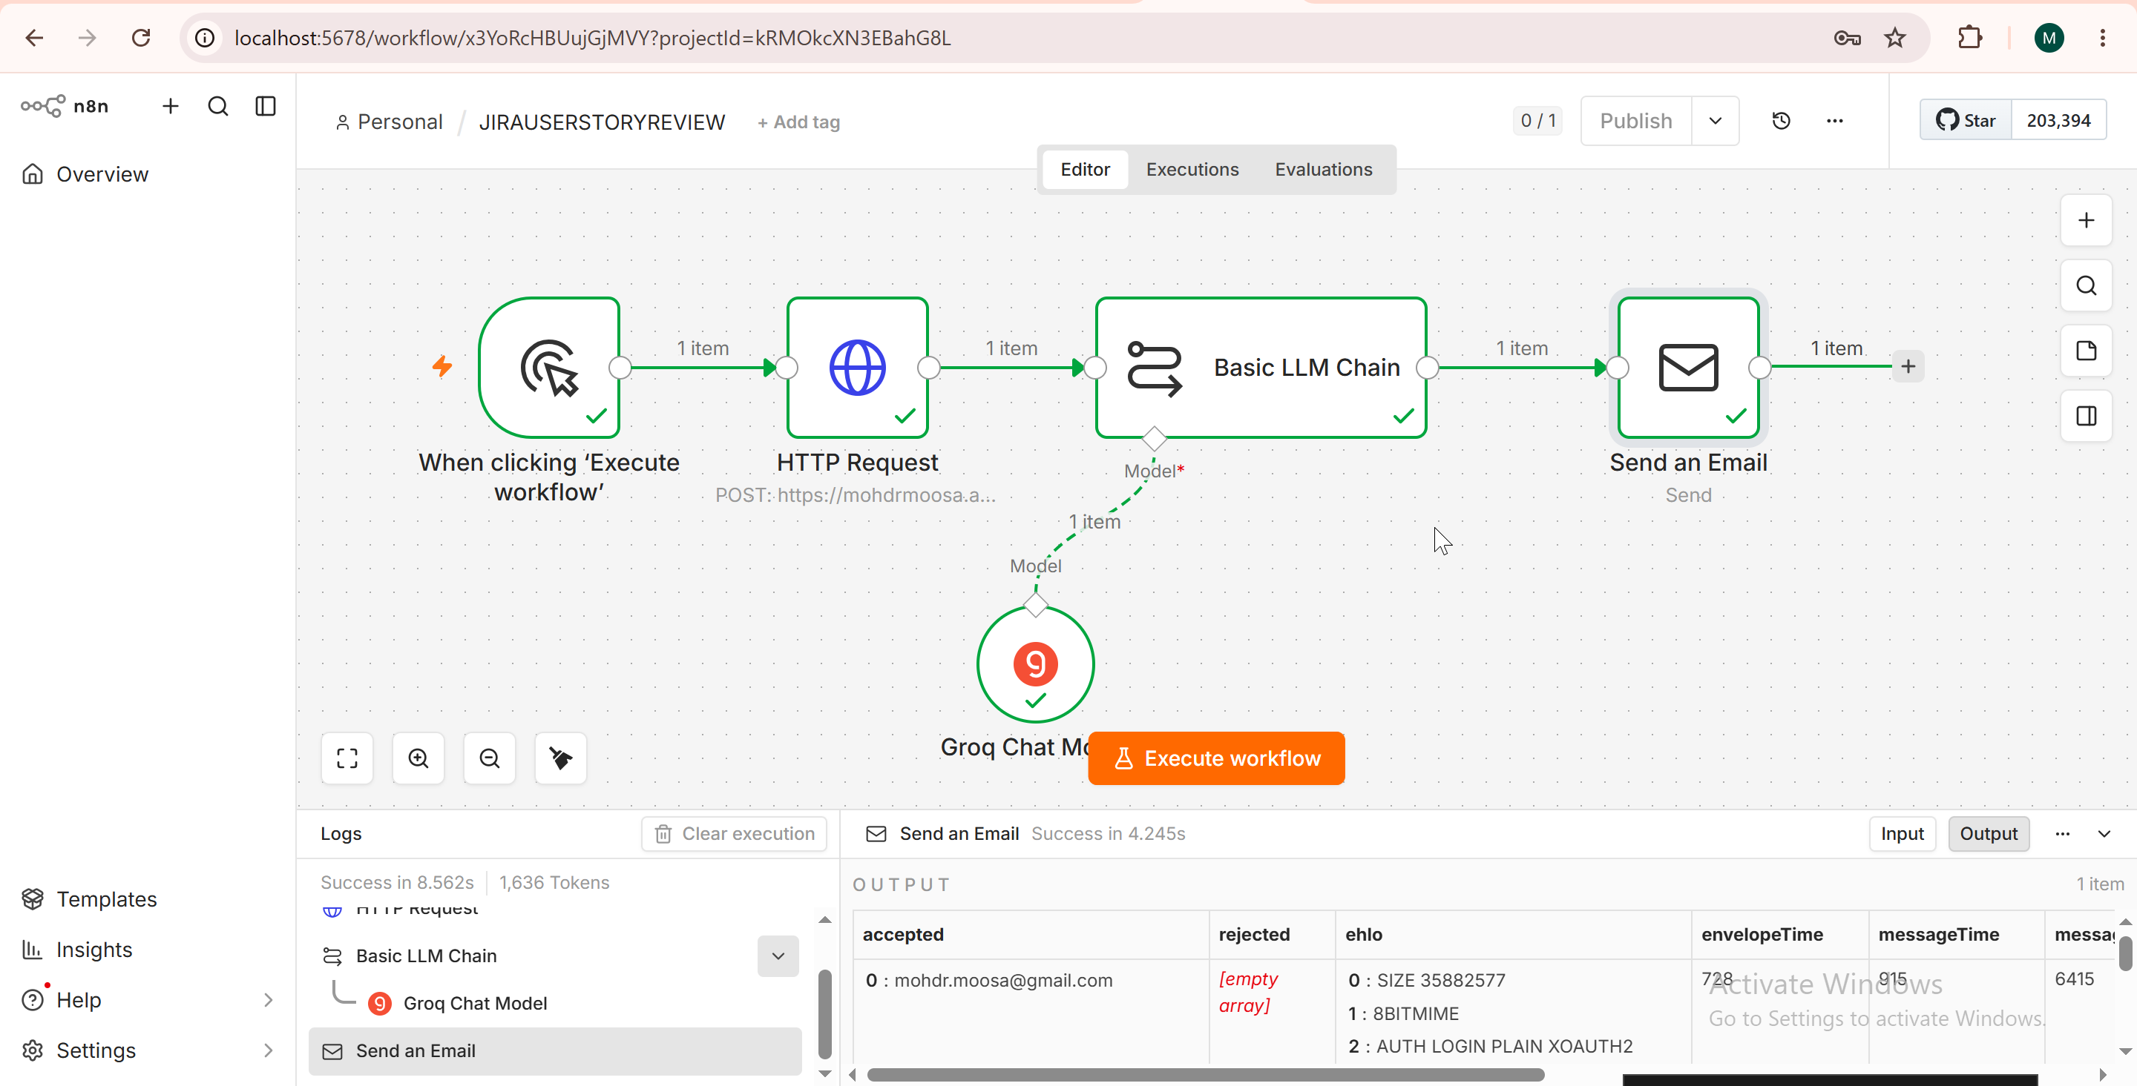
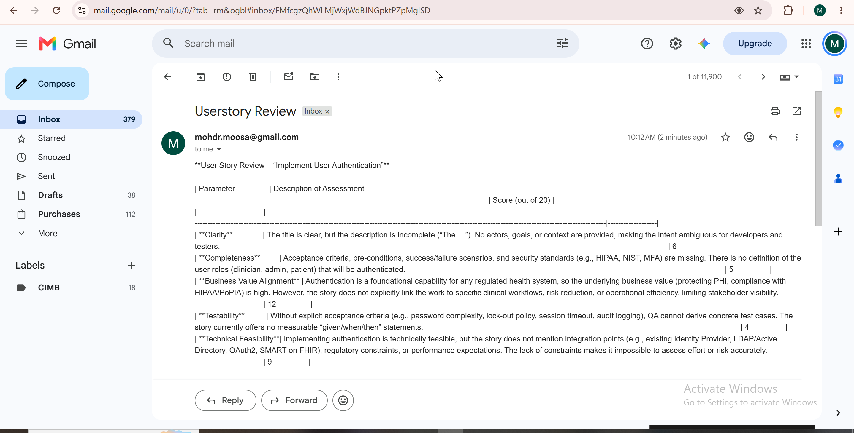

MULTIPLE USER STORY REVIEW

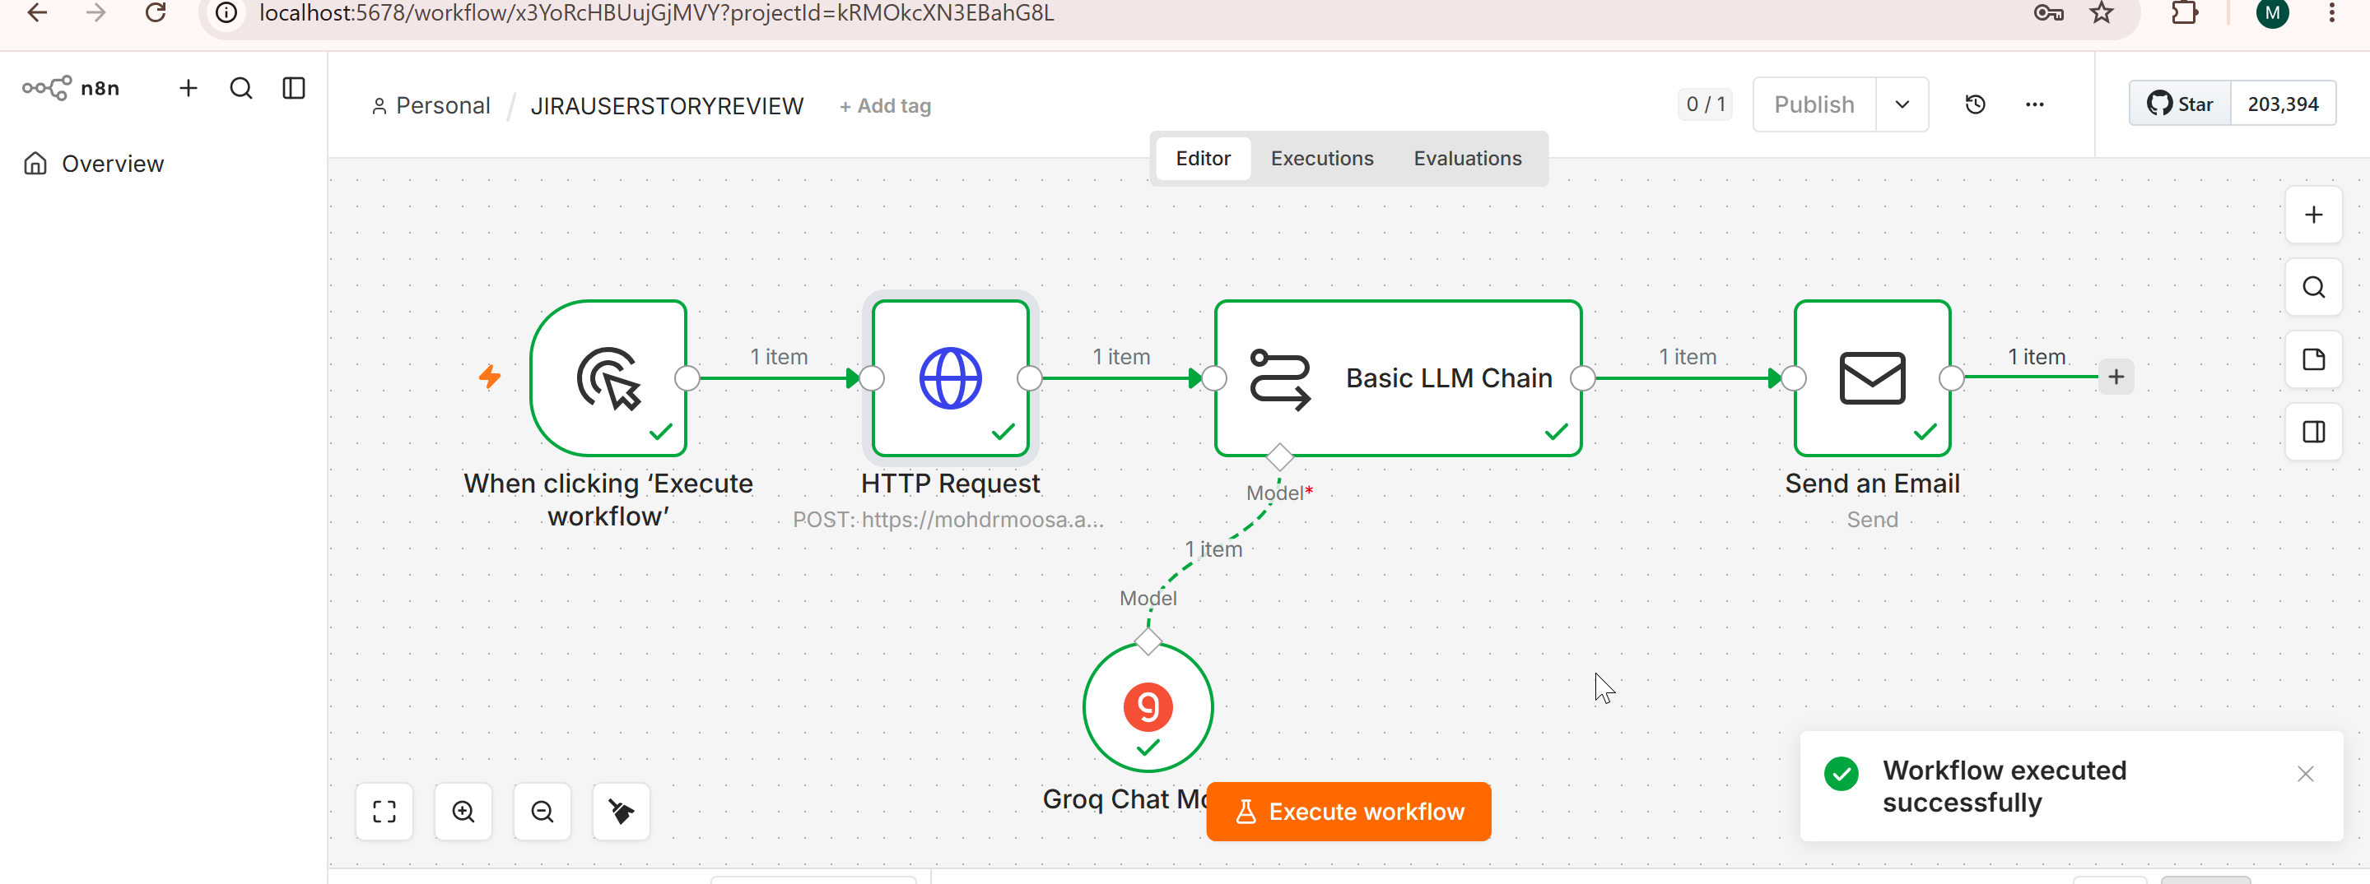

Custom UI Build and JIRA User Story Review
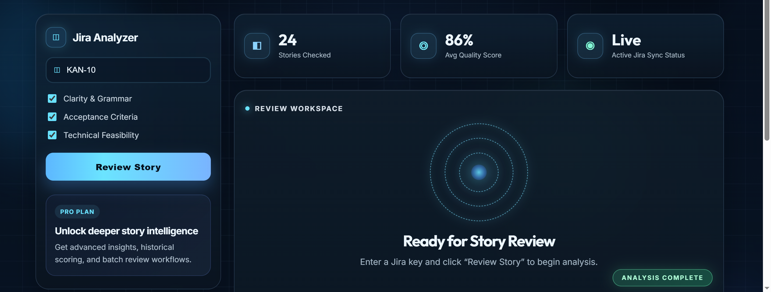

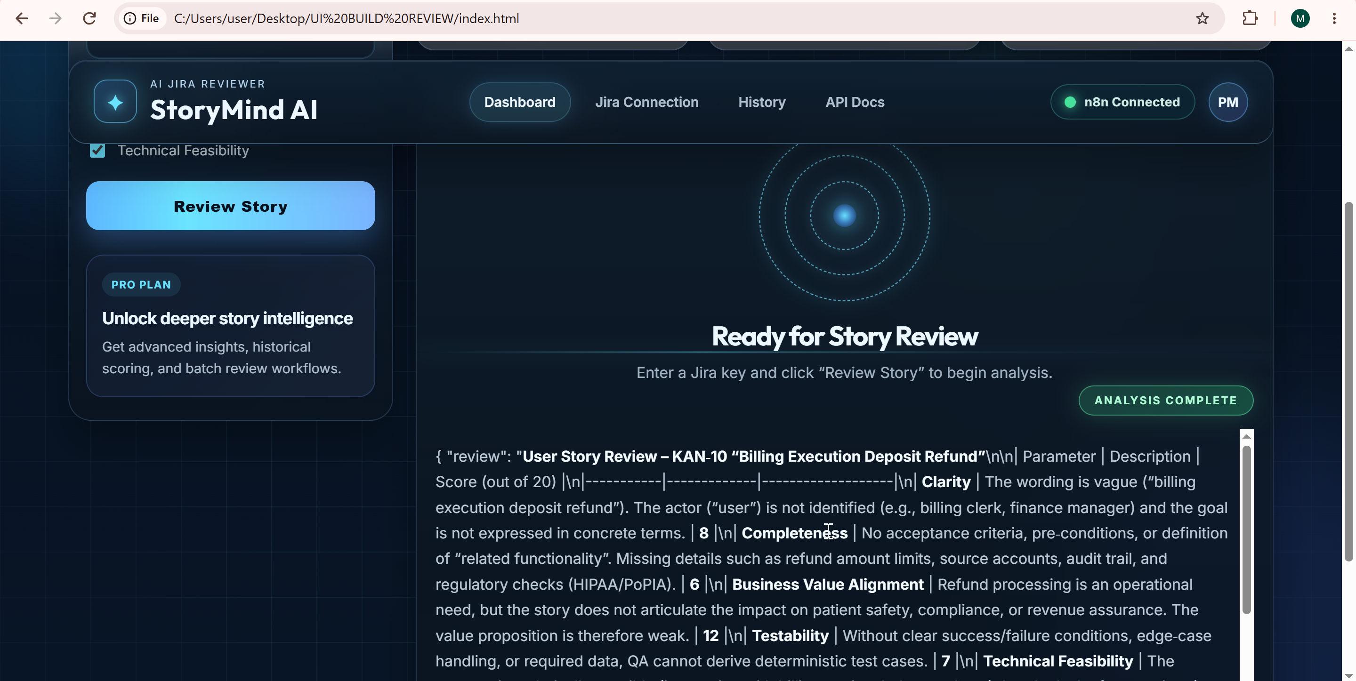

Home Assignment
GITHUB CODE REVIEW AGENT
GitHub Code Reviewer Agent with Custom UI

Using the User Story Reviewer workflow and UI files as a reference, build a custom UI for the existing GitHub Code Reviewer Agent.

Update the n8n workflow by adding a Webhook node as the first node and a Respond to Webhook node as the final node. Create your own phase-wise UI development prompt, build the UI, and connect it to the n8n workflow.

Customize the UI based on your organization’s branding, including:

- Organization name and logo
- Brand theme and colours
- Professional header and footer
- Suitable fonts, buttons, icons, and layout
- Responsive design for desktop, tablet, and mobile
- Loading, success, validation, and error messages
- Any other relevant organization-specific enhancements

Submission Requirements

Submit the following items in both the WhatsApp group and your GitHub repository:

- Phase-wise implementation file
- Complete UI development prompt file
- n8n GitHub Code Reviewer workflow file
- Complete UI source-code files
- Screenshot of the complete n8n workflow
- Screenshots of the final UI and code-review results
- GitHub repository link
- Short demo video, if required

Ensure that the complete application is tested and working correctly before submission.

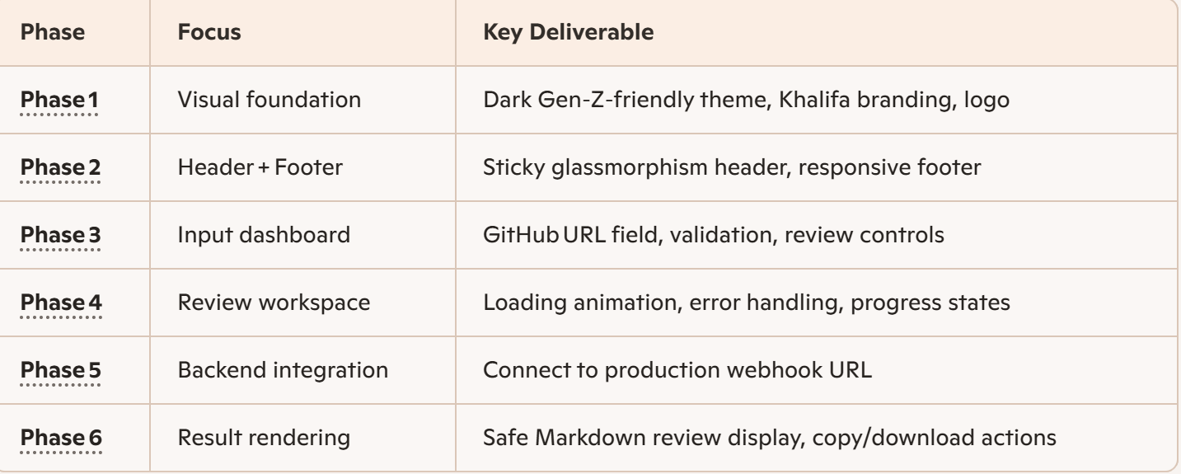
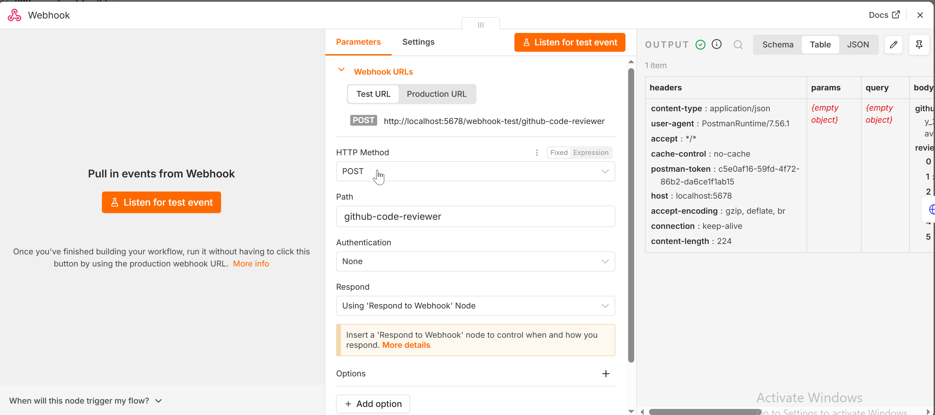
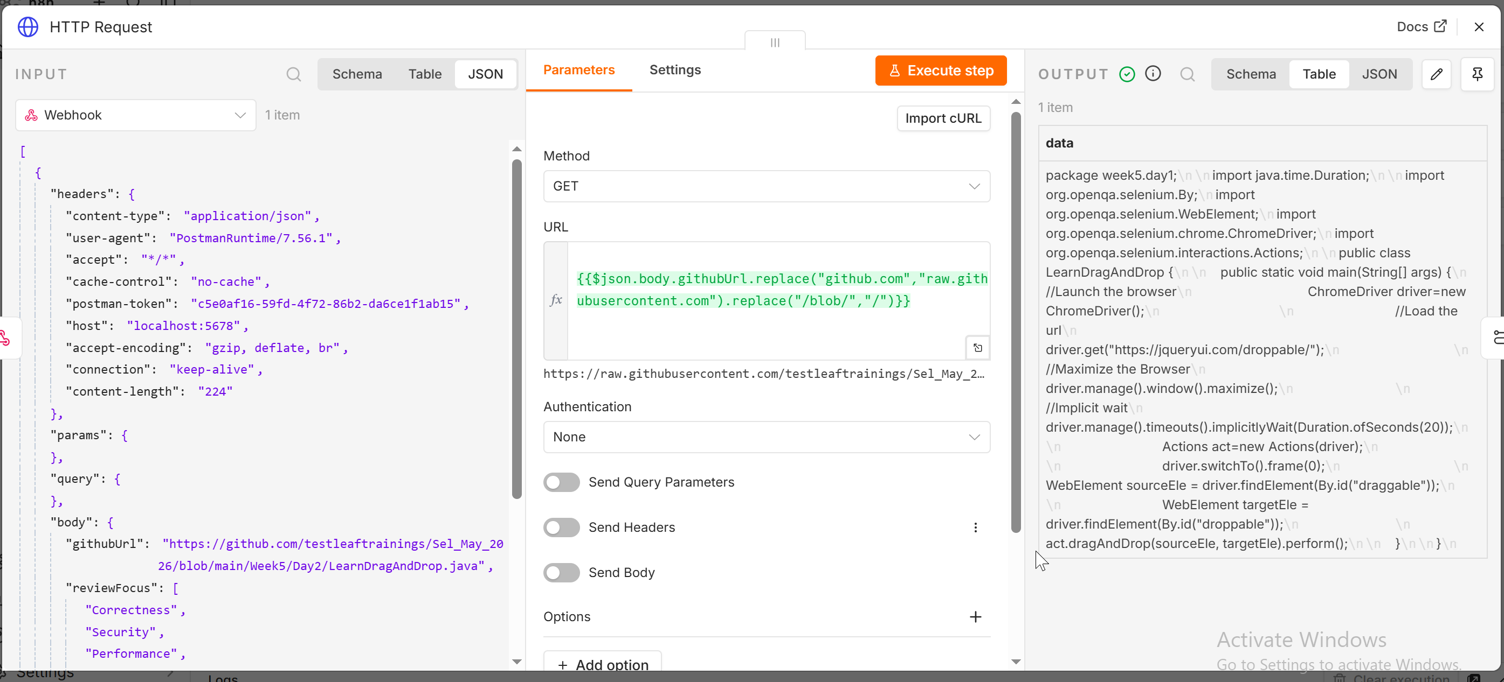
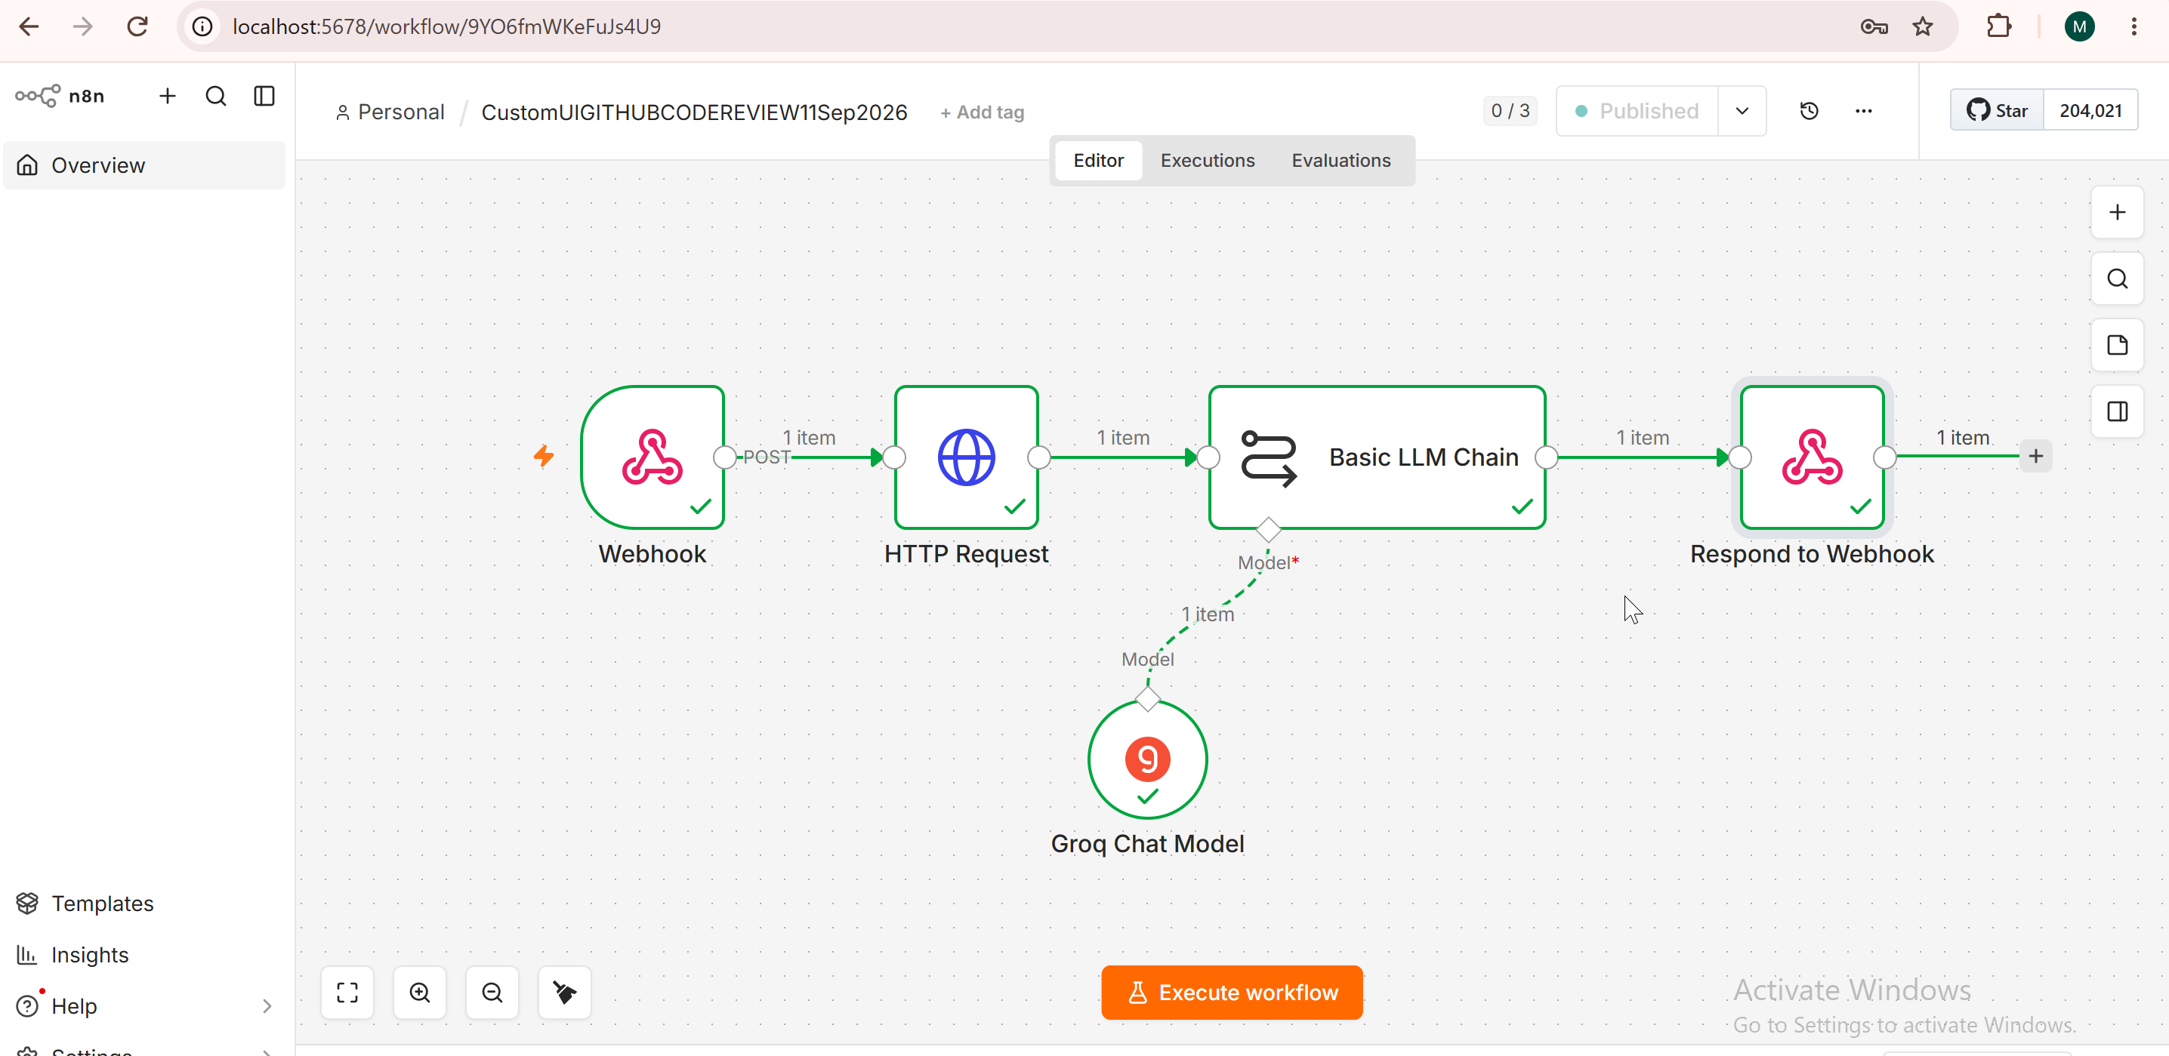

Custom UI Phase 1
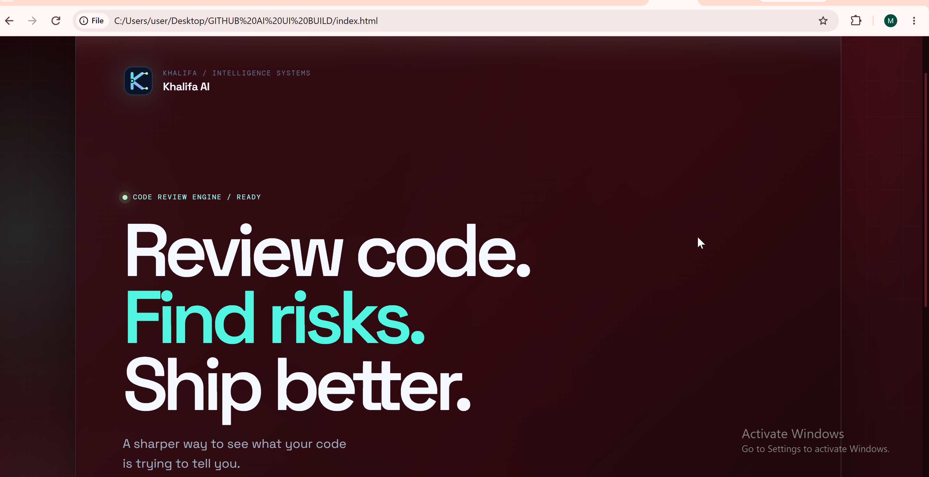

Phase 2
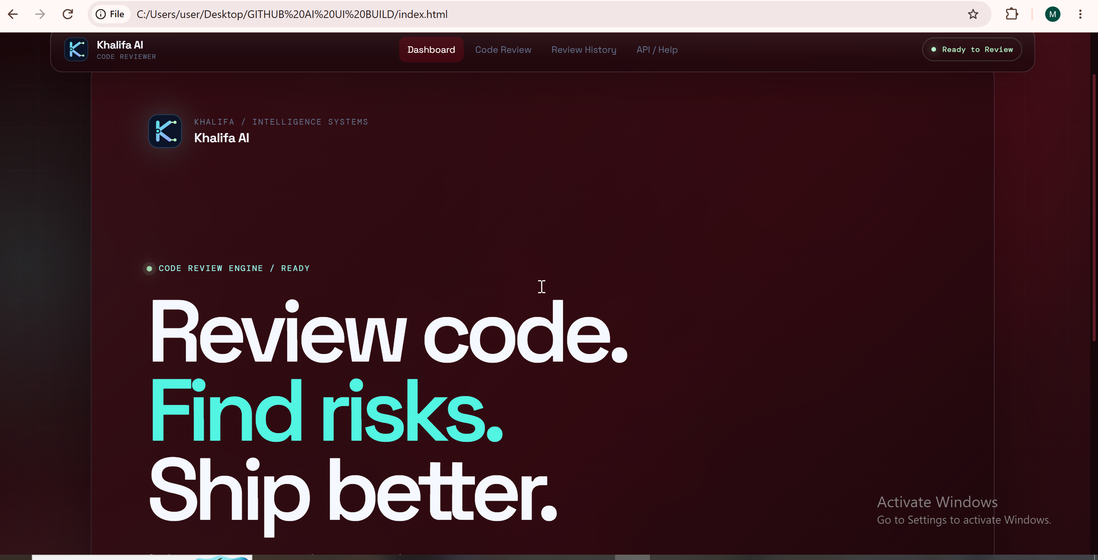
Phase 3
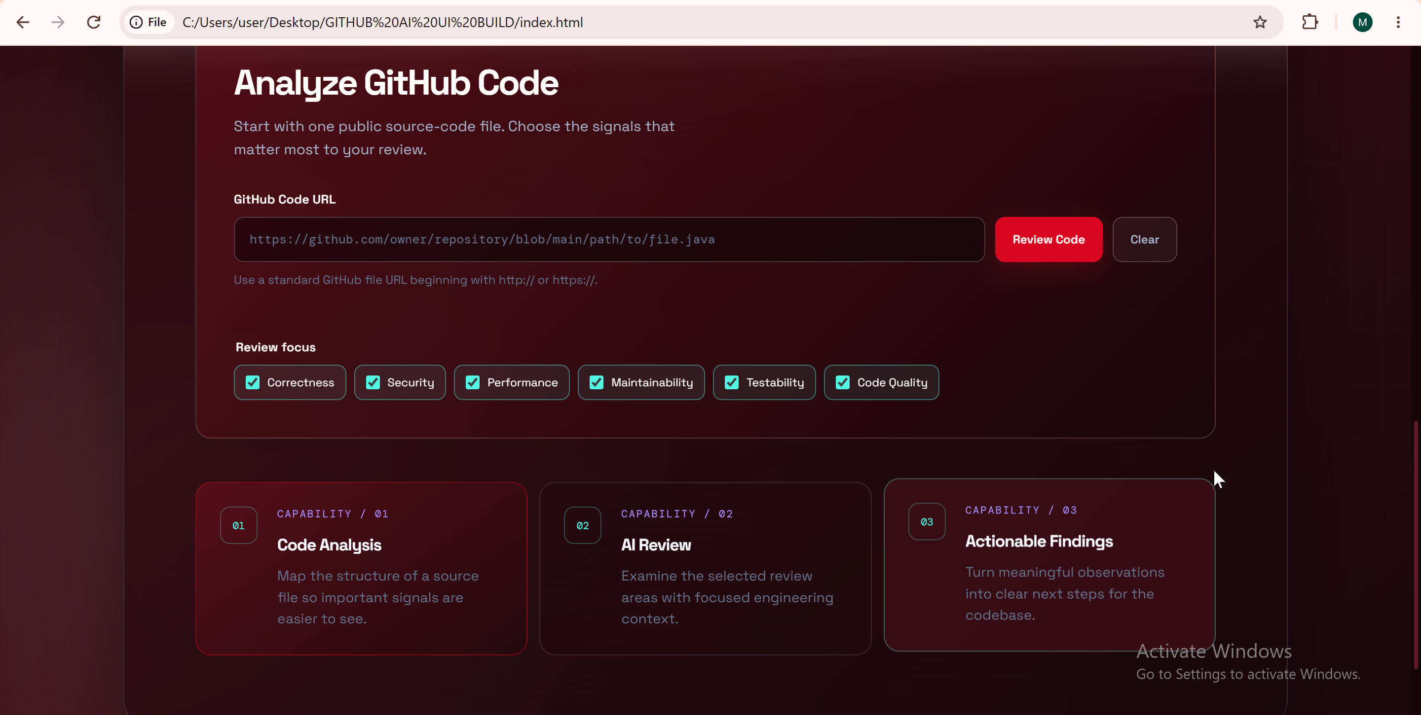

Phase 4
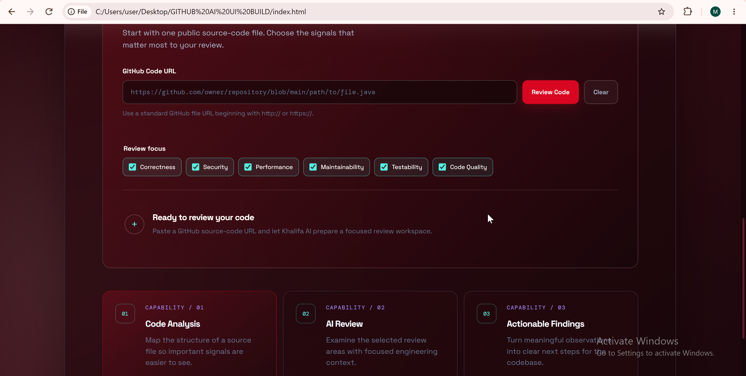
Phase 5
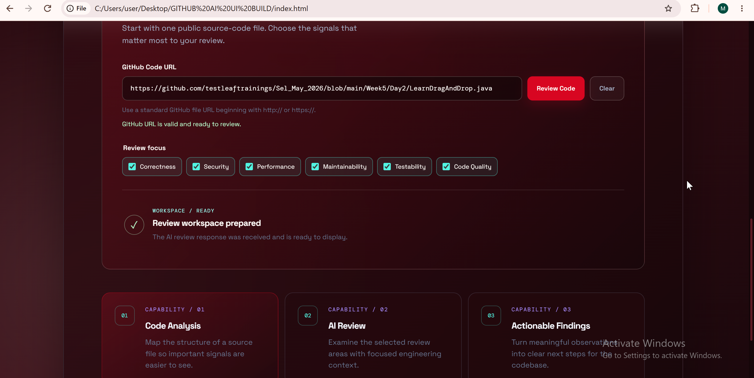

Phase 6

